**CARMEL COLLEGE MALA**

**Nationally Re-accredited with ‘A’ grade (Third Cycle)**

MALA P.O.-680732

Thrissur, Kerala

Phone : 0480-2890247 (Off), 2894706(Resi)

E-mail : [carmelcollege@rediffmail.com](mailto:carmelcollege@rediffmail.com)

Website : www.carmelcollegemala.ac.in

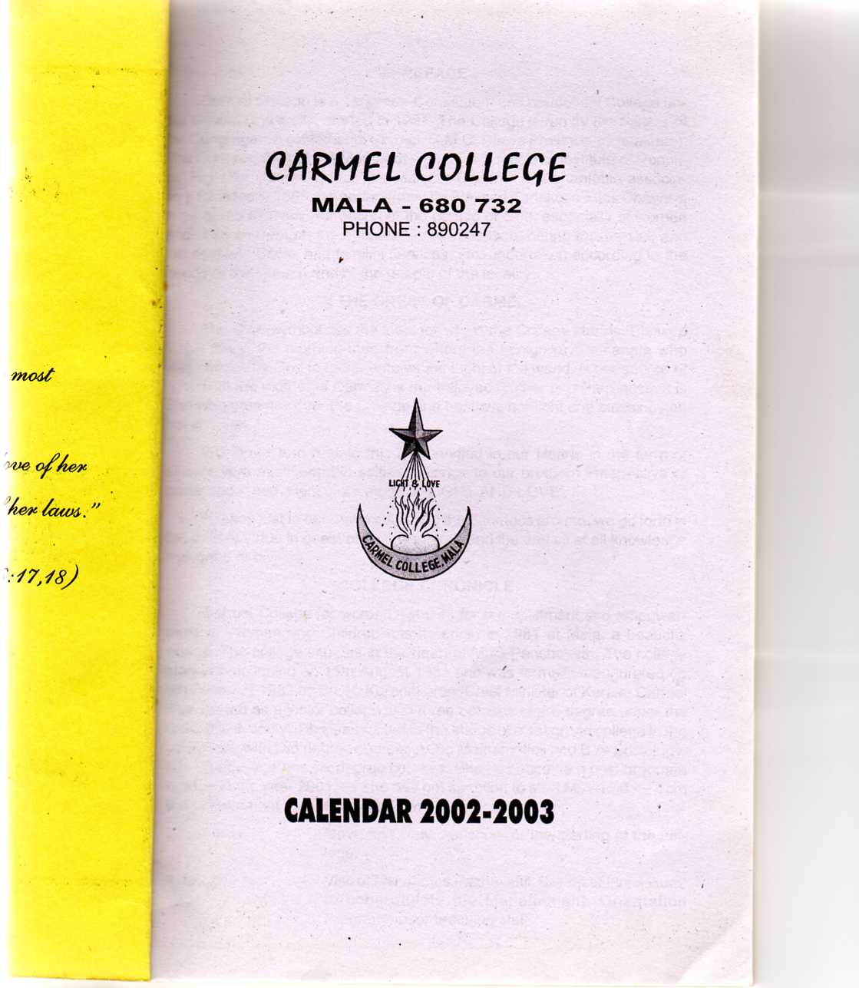

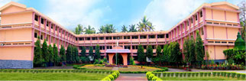

***PROSPECTUS***

***2016-17***

**College Profile**

Carmel College is a First grade College for women started in 1981 affiliated to the University of Calicut. The College has been Re-accredited at ‘A’ grade in the Third Cycle in 2016 and belongs to C.M.C. Educational society of Udaya Province of the congregation of Mother of Carmel.

The objective of the College is to contribute effectively towards the cause of women,s education, so as to make them partners in India,s socio-economic progress. This object shall be obtained through the pursuit of academic excellence and training in moral integrity and social responsibility in a spirit of service to God and man. The college admits all students irrespective of religion, caste and creed.

**VISION**

It is our vision to uplift the weak & downtrodden sections of society, especially that of the rural woman, to liberate her from the shackles of bondage to a new world of ‘light’ & ‘love’.

**MISSION**

We dedicate ourselves to the cause of empowering rural women with knowledge and inculcating in them the spirit of selfless love and compassion, to spread peace in the society, living in harmony with nature and to illumine the world to eternity.

**COURSES**

The Under Graduate Programs are offered under Choice Based Credit Semester System. The duration of the Program is 6 semesters distributed in a period of 3 years. The odd semester will start in June and will end up in October and even semester will start in November and will end up in March. Each semester will have a minimum of 90 working days.

For passing the Degree Program, a student should have achieved a minimum of 120 credits in three years of study.

The Under Graduate Programs include 4 types of courses:

**A. Common Courses :**

English and Languages (Malayalam/Hindi)

**B. Core Courses:**

All students should complete 10 to 18 core courses of 50 credits, which belong to the main subject, during their Degree Program.

**C. Complementary Courses:**

All students should complete 24 credits of one or two disciplines which are related to the core subject during their entire degree

**D. Open Courses:**

All students should study a course other than the core subjects during the 5th semester which will have a weightage of 4 credits.

**ACADEMIC PROGRAMMES**

**Under Graduate Programmes**

**A) Common Courses:** English and Languages (Malayalam/Hindi)

|  |  |  |  |  |  |
| --- | --- | --- | --- | --- | --- |
| Program |  | (B) Core Course(Main) | (C)Complementary Courses (Subsidiaries) | Students Intake |  |
| **B.Sc.** |  | Applied Physics | Mathematics & Computer Application | 24 |  |
|  | Botany | Zoology & Chemistry | 20 |  |
|  | Chemistry | Mathematics & Physics | 24 |  |
|  | Mathematics | Statistics & Computer Application | 24 |  |
|  | Zoology* | Chemistry and Botany | 24 |  |
| **B.A.** |  | Sociology | Modern Indian History & Indian Constitution and Politics | 30 |  |
|  |
|  | Political Science* | Sociology & Modern Indian History | 40 |  |
|  |  | Functional English | Landmarks in English Literature, Indian Writing in English, Personality Development, Foundations of Aesthetics and Criticism | 24 |  |
|  | History* | General Economics &Indian Constitution and Politics | 40 |  |
|  |
| **B.Com.** |  | Commerce* | Commerce & Management Subjects | 40 |  |
|  | Commerce* | Commerce & Management Subjects | 40 |  |
| **B.C.A.** |  | Computer Science* | Mathematics, Statistics & Commerce | 24 |  |
| **B.B.A** |  | Commerce* | Commerce & Management Subjects | 40 |  |

*Self financing programme

**D. The Open Courses offered in the College are:**

|  |  |  |  |  |  |  |  |  |  |  |
| --- | --- | --- | --- | --- | --- | --- | --- | --- | --- | --- |
| **No.** |  |  | **Name of the Course** | |  | **Department** |  | **Student** | | |
|  |  |  |  |  | | **intake** |  |
|  |  |  |  |  |  |  |  |  | |  |
| 1 | Non Conventional Energy Sources | | | |  | Physics |  | 40 | | |  |
| 2 | Tissue Culture | | | |  | Botany |  | 40 | | |  |
| 3 | Environmental Chemistry | | | |  | Chemistry |  | 40 | | |  |
| 4 | Mathematics for Natural Science | | | |  | Mathematics |  | 40 | | |  |
| 5 | Life Skill Education | | | |  | Sociology |  | 40 | | |  |
| 6 | Human Rights in India | | | |  | Political Science |  | 40 | | |  |
| 7 | Advertising: Theory & Practice | | | |  | English |  | 40 | | |  |
| 8 | Basics of Entrepreneurship and Management | | | |  | Commerce |  | 40 | | |  |
| 9 | Hospitality Management | | | |  | Business Administration |  | 40 | | |  |
| 10 | Introduction to Computers and Automation | | | |  | Computer Science |  | 40 | | |  |
| 11 | Reproductive Health and Sex Education | | | |  | Zoology |  | 40 | | |  |
|  | | | |

**B.Voc Programmes**

|  |  |  |
| --- | --- | --- |
|  |  |  |
| **Sl.No.** | **Course** | **Student intake** |
| 1. | Software Development * | 50 |
| 2. | Multimedia* | 50 |

*Self financing programme

**Post Graduate Programmes**

|  |  |  |
| --- | --- | --- |
| **Sl.No.** | **Course** | **Student intake** |
|  | M.A. History | 12 |
|  | M.A. Sociology * | 20 |
|  | M.A. English* | 15 |
|  | M.Sc. Mathematics* | 20 |
|  | M.Sc. Botany | 12 |
|  | M.Com*- Finance | 15 |
|  | M.Com*- Finance | 15 |
|  | M.Sc.*- Chemistry | 10 |
| *Self financing programme | | |

**DIPLOMA COURSES:**

**Community College**

|  |  |  |
| --- | --- | --- |
| **Sl.No.** | **Course** | **Student intake** |
| 1. | DTP & Printing Technology | 50 |

**Computer Courses**

PGDCA, DCFM, DCA, CWD, CCA, CEO, CDECO and other short term certificate courses are offered by CDIT under Govt. of Kerala. Short term certificate courses offered by Indian Computer Education Society (ICES) are also available.

**Career Oriented Courses**

Human Rights Education, NGO Management, Bioinformatics, Plant Tissue Culture, Health Care and Waste Management, Guidance and Counselling, Language Acquisition Skills, Fundamentals of Refrigeration.

**ADMISSION PROCEDURES**

All the candidates who get allotment should report for admission as per the date earmarked in the schedule, at the college concerned after remitting the **University mandatory fee**. The candidates should produce the following documents in **original** before the Principal/Head of the college/Institution at the time of admission for verification.

1. Admit Card (Only for students received allotment)

2. The print outs of the application

3. Receipt/Challan of the fee remitted for acceptance of allotment. (University mandatory fee and

registration fee).

4. Age proof

5. Qualifying Certificate.

6. Mark List(s) of the qualifying examination.

7. Transfer Certificate received from the Institution last studied.

8. Conduct Certificate

9. S.S.L.C

10. Those candidates who have passed examinations other than HSE/VHSE except CBSE/CISCE

should produce Equivalency/Recognition Certificate.

11. Non Creamy layer Certificate / Nativity Certificate /Community Certificate/EWS Certificate as

directed by the admitting authorities

12. Candidates who claim bonus/weightage marks shall produce relevant certificate in original for the

claiming bonus mark at the time of admission.

* NCC
* NSS
* State Arts Festival
* Illiteracy Eradication
* Certificates concerning widows and children of Jawans and Ex-Servicemen and Border Security Force Personnel Killed or disabled in an action.
* Physical Disability
* Sports/Games
* Certificates belonging to SC/ST/OEC/OBC should produce their community certificate

**Eligibility for Admission**

**B.Sc. Applied Physics (Seats: 24):** Candidates who have passed (eligible for Higher Studies) the HSE of the Kerala State Board of Higher Secondary Examination or any other examination recognized as equivalent there to with science subjects are eligible for admission.

**B.Sc. Botany (20seats):** Candidates who have passed (Eligible for higher Studies) the HSE of the Kerala State Board of Higher Secondary Examination or any other examination recognized as equivalent there to with Biology as a compulsory paper are eligible for admission

**B.Sc. Chemistry (Seats 24):** Candidates who have passed (Eligible for Higher Studies) the HSE of the Kerala State Board Higher Secondary Examination or any other examination recognized as equivalent there to with science subjects are eligible for admission.

**B.Sc. Mathematics(Seats 24):** Candidates who have passed (Eligible for Higher Studies) the HSE of the Kerala State Board of Higher Secondary Examination or any other examination recognized as equivalent there to with Mathematics group only are eligible for admission to B.Sc. Mathematics.

**B.Sc. Zoology (Seats 24):** Candidates who have passed (Eligible for higher Studies) the HSE of the Kerala State Board of Higher Secondary Examination or any other examination recognized as equivalent there to with Biology as a compulsory paper are eligible for admission.

**B.A. Functional English (Seats 24):** Candidates Who Have Passed (Eligible For Higher Studies)The HSE Of The Kerala State Board Of Higher Secondary Examination Or Any Other Examination Recognized As Equivalent Thereto Are Eligible For Admission.

**B.A. Sociology (Seats 30):** Candidates who have passed (Eligible for Higher Studies)the HSE of the Kerala State Board of Higher Secondary Examination or any other examination recognized as equivalent thereto are eligible for admission.

**B.A. Political Science (Seats 40):** Candidates who have passed (Eligible for Higher Studies)the HSE of the Kerala State Board of Higher Secondary Examination or any other examination recognized as equivalent thereto are eligible for admission.

**B.A. History (Seats 40):** Candidates who have Passed (Eligible for Higher Studies)the HSE of the Kerala State Board of Higher Secondary Examination or any other examination recognized as equivalent thereto are eligible for admission.

**B.Com Computer Application (Seats 40):** Candidates who have passed (Eligible for Higher Studies) the HSE of the Kerala State Board of Higher Secondary Examination or any other examination recognised as equivalent thereto with at least one commerce subject are eligible for admissions to the B.Com degree course. Candidates who have not studied commerce subject for Higher Secondary or an equivalent examination not less than 45% marks are also eligible. A concession of 5% will be given to OBC/OEC candidates. The SC/ST candidates need get only a pass. (U.O. No.GAI/A2/1658/2007 dated 28.02.2008).

**B.Com Finance (Seats 40):** Candidates who have passed (Eligible for Higher Studies) the HSE of the Kerala State Board of Higher Secondary Examination or any other examination recognised as equivalent thereto with at least one commerce subject are eligible for admissions to the B.Com degree course. Candidates who have not studied commerce subject for Higher Secondary or an equivalent examination not less than 45% marks are also eligible. A concession of 5% will be given to OBC/OEC candidates. The SC/ST candidates need get only a pass. (U.O. No.GAI/A2/1658/2007 dated 28.02.2008).

**BBA (Seats 40):** Candidates who have passed (Eligible for Higher Studies)the HSE of the Kerala State Board of Higher Secondary Examination or any other examination recognized as equivalent thereto, with not less than 50% is eligible for admissions. A concession of 5% will be given to OBC/OEC candidates. The SC/ST candidates need get only a pass. (U.O.No.GAI/J2/2907/2003 dated concerned

**BCA (Seats 24):** Candidates who have passed (Eligible for Higher Studies)the HSE of the Kerala State Board of Higher Secondary Examination or any other examination recognized as equivalent thereto with Mathematics/ Computer Science/Computer Application/ Information Technology/Informatics Practice/Informatics/ Additional Mathematics as one of the subjects are eligible for admissions (U.O. No.GAI/J1/2453/1997 dated 06.10.2000 and GA I/J1/1597/2005 dated 11.07.2005).

**B.Voc Software Development (Seats 50):** Candidates who have passed (Eligible for Higher Studies) the HSE of the Kerala State Board of Higher Secondary Examination or any other examination recognized as equivalent thereto with Mathematics/ Computer Science/Computer Application/ Information Technology/Informatics Practice/Informatics/ Additional Mathematics are eligible for admission. (U.O.No.GAI/JI/4756/1999 dated 11.01.2002)

**B.Voc Multimedia (Seats 50)** **:** Candidates who have passed (Eligible for Higher Studies) the HSE of the Kerala State Board of Higher Secondary Examination or any other examination recognized as equivalent thereto with not less than 45% marks in aggregate shall be eligible for admission. A concession of (5%) will be given to OBC/OEC candidates. The SC/ST candidates need get only a pass (Eligible for Higher Studies)

**M.A. History (Seats 12) :** Any First Degree of this University or equivalent degree with at least 50% marks or equivalent grade for Part-III excluding subsidiaries. OBC/OEC candidates are eligible for relaxation upto 5%, SC/ST candidates need only to get a pass.

**M.A. Sociology (Seats 20) :** Under Mark System :- Any UG Degree of this University or equivalent degree with at least 45% marks for Part III (excluding subsidiaries). OBC/OEC candidates are eligible to relaxation up to 5%. SC/ST candidates need only to get a pass.

Under Grade System:- Any UG Degree of this University or equivalent degree with each Core and Complementary course grade point at least equivalent to 50%. OBC/OEC candidates are eligible to relaxation up to 5%. SC/ST candidates need only to get a pass.

**M.A. English (Seats: 15):** Under Mark System :- BA English Lang. & Litt./BA English & History/BA Functional English with at least 45% marks for English Main Papers or BA/BSc (excluding alternative pattern) Degree with at least 45% marks in Part I English, of this University or equivalent degree. OBC/OEC candidates are eligible to relaxation up to 5%. SC/ST candidates need only to get a pass.

Under Grade System :- BA English Lang. & Litt./BA English & History/BA Functional English/ or BA/BSc (excluding alternative pattern) Degree with English as Common Course of this University or equivalent degree with Overall CGPA, at least equivalent to 50%. OBC/OEC candidates are eligible to relaxation up to 5%. SC/ST candidates need only to get a pass.

**M.Sc. Botany (Seats 12):** Bachelor degree in Botany or Plant Science of University of Calicut or equivalent qualification with a minimum of 50% marks in the main (core) subject under the mark system or equivalent grade under the grade system, with 45% marks or equivalent grade in the case of OBC/OEC candidates and with a pass in the case of SC/ST candidates.

**M.Sc. Mathematics (Seats 20) :** B.Sc. Degree in Mathematics or an equivalent degree with at least 50% marks or equivalent grade in Core and at least 50% marks or equivalent grade in Part III (Core and Complementary put together) . OBC/OEC candidates are eligible to relaxation up to 5%. SC/ST candidates need only to get a pass.

**M.Sc. Chemistry (**Seats: 10) Under Mark System :- BSc Degree of this University with Chemistry/Industrial Chemistry/Polymer Chemistry (Main) or equivalent degree with Mathematics as one of its subsidiaries with at least 50% marks. OBC/OEC candidates are eligible to relaxation up to 5%. SC/ST candidates need only to get a pass.

Under Grade System :- B.Sc. Degree of this University with Chemistry/Industrial Chemistry/Polymer Chemistry (Core) with Mathematics as one of its subsidiaries or equivalent degree with Overall CGPA, at least equivalent to 50%. OBC/OEC candidates are eligible to relaxation up to 5%. SC/ST candidates need only to get a pass.

**M.Com Finance (Seats 30):**  Any candidate who has passed B.Com or BBA (earlier BBS) degree of University of Calicut or B.Com, BBA, BBM or BBS degree of any other University or Institutes in any states recognized by UGC or AICTE and approved by University of Calicut with minimum of 45% marks or equivalent grade is eligible for admission. OBC and SC/ST students are eligible for mark/grade relaxation as per the University rules. In the case of B.Com (Honours) students, the minimum eligibility for admission is 50% for all categories of students.

**SEAT DISTRIBUTION**

**Aided Courses**

|  |  |  |
| --- | --- | --- |
| Sl.No. | Seat Reservation | % of Reservation |
| 1 | Open merit Quota | 50 |
| 2 | Scheduled Caste | 15 |
| 3 | Scheduled Tribe | 5 |
| 4 | Community Quota | 10 |
| 5 | Management Quota | 20 |

**Self- Financing Courses**

50% of the total seats shall be filled by the management from among candidates of their choice provided they satisfy the eligibility conditions. The remaining seats (50%) shall be distributed and filled as follows:

|  |  |  |
| --- | --- | --- |
| Sl.No. | Distribution of 50% seats earmarked under merit | % of Reservation |
| 1 | Open merit Quota | 65 |
| 2 | Scheduled Caste | 8 |
| 3 | Scheduled Tribe | 2 |
| 4 | Ezhava/Thiyya/Billava | 9 |
| 5 | Muslim | 8 |
| 6 | Latin Catholics other than Anglo Indians | 2 |
| 7 | Other Backward Christians | 1 |
| 8 | Other Backward Hindus | 5 |

Those who wish to get admission to the all seats in our college shall apply online in CAP (https://admission.uoc.ac.in/). However, those who wish to get admission to the management seats shall register through CAP and apply Management application to college office.

|  |
| --- |
| **MOBILE PHONE IS STRICTLY PROHIBITED IN THE CAMPUS.**  **RAGGING EVEN OF ANY SIMPLE NATURE IS PUNISHABLE.** |

